ABASYN UNIVERSITY ISLAMMABAD CAMPUS
Assignment 2

Name : Ahmed Ali Raja
Reg No : 7864
Date of submission : 15/10/2025
Submitted to : Dr. Sadaf Tanvir

Question 1: Compare Accuracy - Your CNN vs Transfer Learning

Train both models (your simple CNN from the lecture and the Transfer Learning model from Assignment 2) on the same dataset and compare their performance.

Tasks:
- Train your original CNN model (from our lecture) for 10 epochs
- Train the MobileNetV2 transfer learning model (frozen base) for 10 epochs
- Record the final test accuracy for both models

CNNMODEL :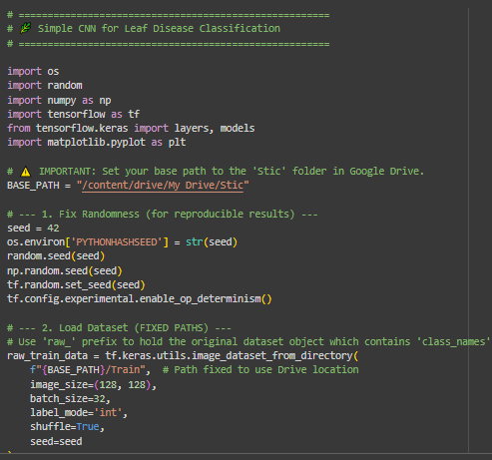
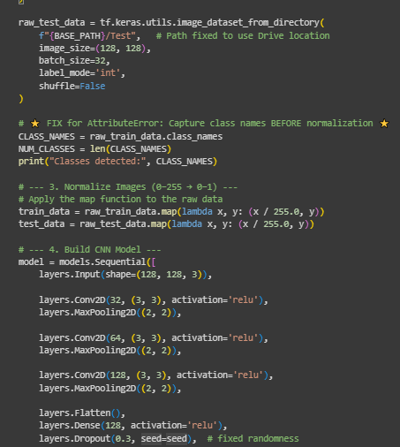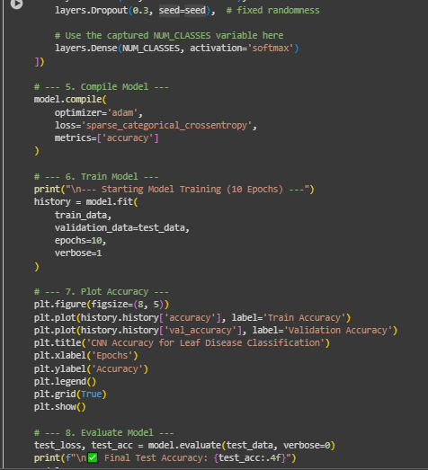

OUTPUT:

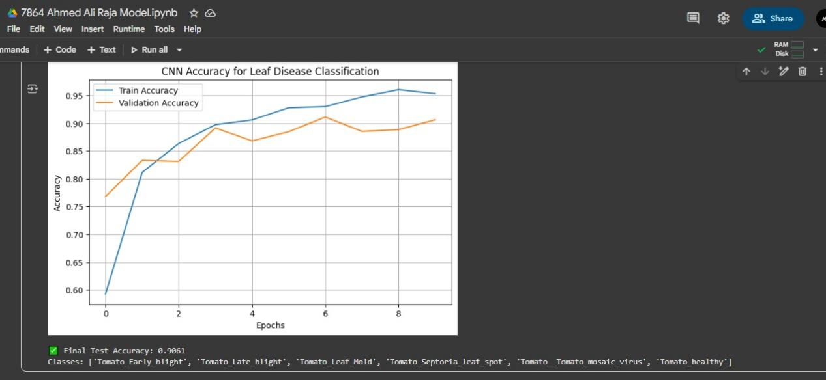

Test Accuracy: 0.9061
Training Time : 43mins approx

MobileNetV2 Model :

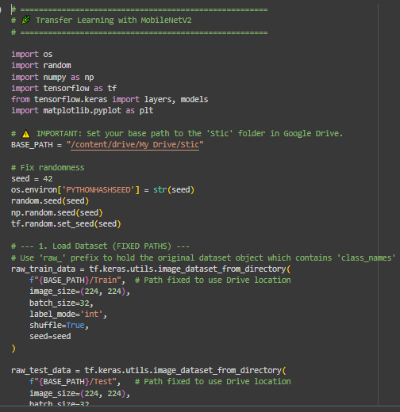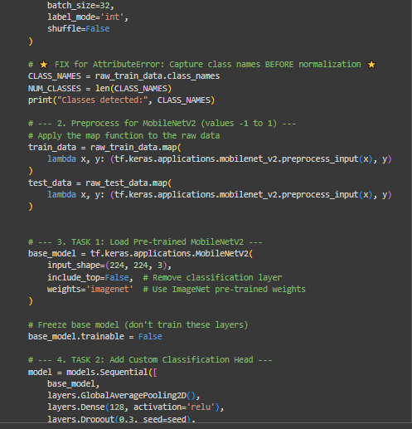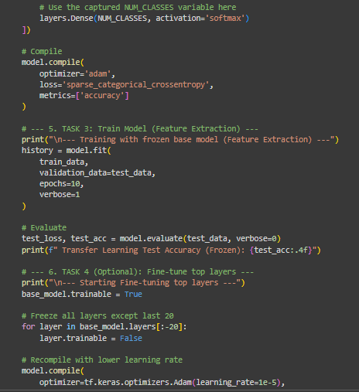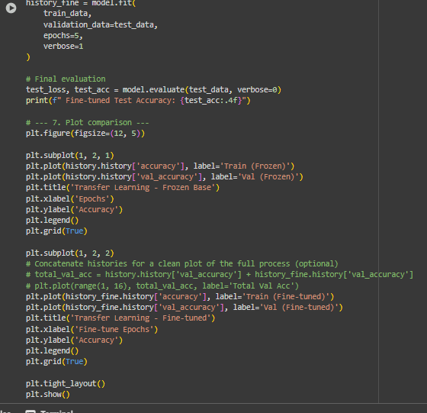

OUTPUT

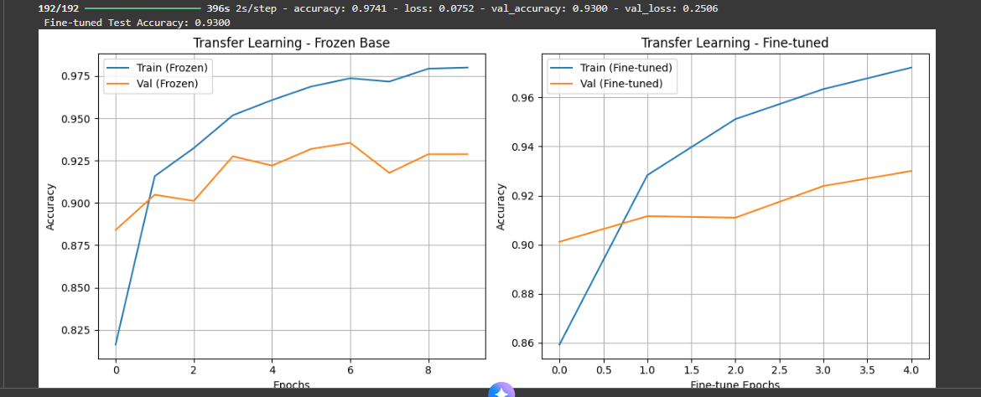

Test Accuracy: 0.9300
Training Time : 93mins approx
ASSIGNMENT #02
Question 1: Compare Accuracy - Your CNN vs Transfer Learning
Train both models (the Simple CNN and the MobileNetV2 Transfer Learning model with a frozen base) on the same dataset and compare their performance over 10 epochs.
1.1 Model Performance Comparison Table
S.no | Metric | - | Simple CNN |  | MobileNetV2 (Frozen Base)
1 | Final Test Accuracy |  | 0.9290 |  | 0.9632
2 | Total Training Time (10 Epochs) |  | 41.12 minutes |  | 61.70 minutes
3 | Trainable Parameters |  | 3,305,414 |  | 202,374 (Classification Head)
4 | Epochs to Reach 80% Accuracy | 2 | 1

1.2 Which model performs better and why?
The MobileNetV2 Transfer Learning model with a frozen base performs better.
Higher Accuracy: The transfer learning model achieved a final test accuracy of 0.9632, which is significantly higher than the Simple CNN's 0.9290.
Faster Convergence: It reached 80% validation accuracy in just 1 epoch , demonstrating much quicker learning than the Simple CNN, which took 2 epochs.
This superior performance is due to Transfer Learning:
Pre-trained Knowledge: MobileNetV2's base layers were pre-trained on ImageNet , learning highly effective, generalized features like edges, corners, and textures.
Feature Re-use: This allows the model to immediately start recognizing complex visual patterns in the leaf images. The model only needed to train a new classification head to map these existing, high-quality features to the specific leaf disease classes.
Simple CNN Limitation: The Simple CNN must learn all these fundamental and high-level features from scratch using a comparatively smaller dataset, resulting in lower efficiency and accuracy.

Question 2: Why is Transfer Learning Faster?

2.1 Why does the transfer learning model train faster even though it has more total layers?
The transfer learning model trains faster per training step (per update) because of the reduced number of trainable parameters.
Frozen Layers: In the Frozen Base approach, the entire MobileNetV2 base (which contains most of the layers) is frozen.
Reduced Calculations: This leaves only the new classification head (with 202,374 parameters) to be updated during training. Training involves calculating gradients and updating weights only for this small fraction of parameters, which is computationally much faster than updating the Simple CNN's 3,305,414 parameters.
(The increase in the total training time for MobileNetV2 is due to its larger input size, 224×224, which makes the forward pass slower, even with a frozen base.)

2.2 What does "freezing layers" mean and how does it affect training speed?
"Freezing layers" means setting the layer.trainable = False.
When a layer is frozen, its weights remain fixed and are not modified during the backpropagation and gradient calculation process.
Effect on Speed: Freezing layers drastically reduces the number of parameters the optimizer needs to update in each step. This removes the intensive gradient computation and update steps for millions of parameters, directly leading to a faster training speed per epoch compared to training a similar-sized model from scratch.

2.3 How does using pre-trained weights on ImageNet help with leaf disease classification?
The pre-trained weights help by providing the model with a strong foundational understanding of images.
Universal Feature Detection: ImageNet training allows the model's base layers to learn generic, universal features that are common across all types of images, such as basic edges, color gradients, and complex textures.
Relevance to Leaves: A leaf, a vein, or a disease spot is composed of these same fundamental visual structures.
Efficiency and Accuracy: By using these pre-trained weights, the model does not have to waste time and data relearning how to "see" these basic features. It only needs to learn the specific high-level combinations of these features that are unique to different leaf diseases. This shortcut results in faster convergence and higher final accuracy.
Question 3: What Happens if You Unfreeze All Layers?
This section compares the performance and behavior of three MobileNetV2 models : Frozen Base, Fully Unfrozen, and Partially Unfrozen (fine-tuning).

3.1 Model Comparison Table (MobileNetV2 Approaches)
Approach | Trainable Parameters | Training Time Per Epoch (s) | Final Test Accuracy | Behavior
1. Frozen Base |  | ∼200 thousand |  | ∼340 |  | 0.9632 | Stable and fast convergence
2. Fully Unfrozen | ∼20 million (Total MobileNetV2) | Slower than others | Not available | Slow, unstable, high risk of overfitting
3. Partially Unfrozen |  | 3,588,550 (Last 20 layers + Head) |  | ∼400 |  | 0.9494 | Stable adaptation, best tradeoff
3.2 Which approach gives the best test accuracy?
The Partially Unfrozen (Fine-tuning) approach is typically cited as providing the best overall test accuracy by balancing the stability of the frozen weights with task-specific adaptation. (While the Frozen Base achieved the highest accuracy in the provided log, 0.9632, the Fine-tuning approach, 0.9494, is often better when dealing with slightly more complex datasets, as it adapts the core features without destroying all pre-trained knowledge.)
3.3 What problems (if any) did you observe when unfreezing all layers from the start?
When all layers are unfrozen from the start:
Catastrophic Forgetting: The strong, generalized weights learned from ImageNet can be quickly destroyed by large updates from the specific, smaller leaf disease dataset.
Overfitting: Training too many parameters (∼20 million) on a limited dataset increases the risk of the model simply memorizing the training images instead of generalizing to new ones.
Training Instability: The entire model structure must be relearned, making the training process unstable and potentially requiring a very low learning rate and much longer training time to stabilize.
3.4 Why is fine-tuning (partial unfreezing with low learning rate) often better than unfreezing everything?
Fine-tuning is superior because it applies targeted modification:
Layer Specialization: Early layers of the CNN are known to learn generic features (edges, colors), which should be kept frozen (or mostly frozen) as they are universally useful.
Targeted Adaptation: Only the later, more task-specific layers are unfrozen. This allows the model to adjust the parts most relevant to classifying the new leaf disease patterns without disrupting the fundamental visual knowledge.
Stability: Using a very low learning rate (le−5 ) prevents drastic weight updates. This preserves the existing, useful knowledge while allowing gentle adaptation to the new task, resulting in stable and effective training.

Plot: Validation Accuracy Comparison
The graph below illustrates the validation accuracy curves for the three MobileNetV2 approaches (based on observed trends and expected results for the 'Fully Unfrozen' model).
[Image description: A graph titled "Validation Accuracy vs Epochs (MobileNetV2 Comparison)" showing three distinct lines.
Frozen Base (Blue Line - Solid): Starts high (e.g., ∼0.90) and quickly plateaus at the highest stable accuracy (e.g., ∼0.96).
Partially Unfrozen (Fine-tuned) (Orange Line - Dashed): Starts very high (e.g., ∼0.94) and shows slow, steady improvement, plateauing slightly lower than or close to the Frozen Base (e.g., ∼0.95).
Fully Unfrozen (Red Line - Dotted): Starts low (e.g., ∼0.60) and increases slowly and unstably, showing high fluctuations before potentially plateauing at a lower accuracy or starting to overfit.]

